Reconstruction Road Map
On a separate sheet of paper, create an illustration of a road that shows the important events of Reconstruction and their impact on African Americans’ journey toward full citizenship. Your road should:
- Show the path of Reconstruction, including progress and setbacks that African Americans experienced in their struggle for full citizenship during Reconstruction

- Include along the path the following 15 events during Reconstruction
        - For each event include
- 13th Amendment
- Freedmen’s Bureau
- Black Codes
- 14th Amendment
- Military Reconstruction Act
- Sharecropping
- 15th Amendment
- New State Constitutions
- African American Officeholders
- Ku Klux Klan
- Enforcement Acts
- Compromise of 1877
- Poll Taxes
- Jim Crow Laws
- Plessy v. Ferguson
        - Name of the event
        - Short explanation/description
        - Symbol or picture that indicates the impact on African American citizenship
          - fast speed limit signs, green lights can be used for progress
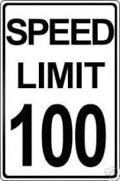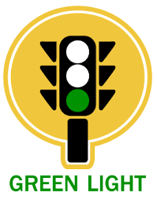
          - detours, stop signs, potholes, roadblocks, construction can be used for setbacks
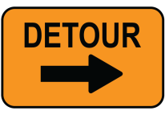

- Your map should have a title and caption at the top of the page
  - The caption should be at least 3-5 sentences
  - The caption will summarize how Reconstruction brought African Americans closer to full citizenship. In what ways did African Americans get closer to full citizenship during Reconstruction? In what ways did African Americans not yet achieve full citizenship?

- Your map must be colorful, neat, and free from spelling errors
  - Layout is important
    - Plan your space so that you have room for all events, vocabulary, and the caption
    - All labels, explanations, and captions should be written neatly

- Class time must be used wisely!

Grading Rubric
 | 20 Points | 15 Points | 10 Points | 5 Points
Name and Explanation of Events | Name & explanation for all 15 events on road map | Name & explanation for 10-14 events on road map | Name & explanation for 5-9 events on road map | Name & explanation for 1-4 events on road map
Symbol or Picture of Event | Picture or symbol for all 15 events on road map | Picture or symbol for 10-14 events on road map | Picture or symbol for 5-9 events on road map | Picture or symbol for 1-4 events on road map
Title and Caption | Title and impressive caption (3-5 sentences) | Title and accurate caption (3-5 sentences) | Title and caption are included, but may be somewhat inaccurate or too short (less than 3-5 sentences) | Title and/or caption may be missing or inaccurate
Quality of Work | High quality work, colorful, neat, no spelling errors, eye catching design | Colorful design, although product may be somewhat unorganized and/or may have errors | Little color is used and/or messy design, several errors that impact the quality of work | Color is not used, messy design, and many spelling errors
Class Participation | Prepared every day, used class time wisely, required no redirection | Used class time wisely and required no redirection but was not always prepared | Did not always use class time wisely and required some redirection to stay on task | Wasted class time and/or caused disruptions

Score: ____________

