**U.S. History Quarter 3 Study Guide**

1. Using key terms from the word bank below, complete the speech bubbles with each president’s foreign and domestic policies.

|  |  |  |  |
| --- | --- | --- | --- |
| Set precedents for future presidents | White House was burned | Alien and Sedition Acts | Adams-Onis Treaty was signed and Florida added to the United States |
| Missouri Compromise | Louisiana Purchase | Monroe Doctrine | XYZ Affair |
| Built roads and canals | Manufacturing increased in the United States during War of 1812 | Neutrality Proclamation | Faced challenge of paying off debt from the Revolutionary War |
| President during War of 1812 | Embargo Act of 1807 | Whiskey Rebellion | President during “Era of Good Feelings” |

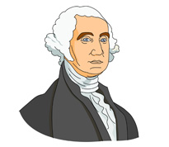

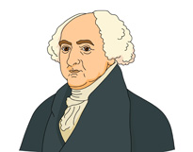

George Washington 1789-1797

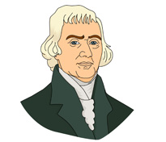

John Adams 1797-1801

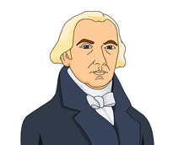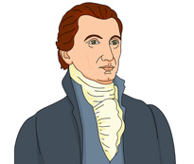

Thomas Jefferson 1801-1809

James Monroe 1817-1825

James Madison 1809-1817

1. Read the following quote from Washington’s Farewell Address and summarize in your own words using the space below.

**…The great rule of conduct for us in regard to foreign nations is in extending our commercial relations to have as little political connection as possible…It is our true policy to steer clear of permanent alliances, with any portion of the foreign world…** -Washington’s Farewell Address

Summarize the main ideas of the passage:

1. Based on the cartoon, which of the following best explains the impact of the Monroe Doctrine?
2. The United States would not allow foreign nations to form alliances
3. The United States would not allow further European colonization in the Western Hemisphere
4. The United States would protect the economic interests of Europe
5. The United States blocked trade between Europe and Africa
6. 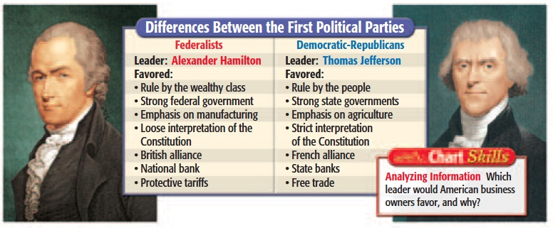Complete the graphic organizer below with causes and effects of the War of 1812.

|  |  |
| --- | --- |
| **War of 1812** | |
| **Causes (Page 313)**  1.  2.  3. | **Effects (Page 317)**  1.  2.  3. |

1. Match the following Supreme Court cases with the correct description.

|  |  |
| --- | --- |
| ________ Marbury v. Madison | 1. Supreme Court ruled that the federal government had the power to set up a national bank due to the “necessary and proper” clause of the Constitution. It also declared that states do not have the power to tax the federal government. |
| ________ McCullough v. Maryland | 1. Supreme Court ruled that the Native Americans could stay on their home lands in Georgia |
| ________ Gibbons v. Ogden | 1. Court case that gave the Supreme Court the power of judicial review. Judicial review gave the Court the power to check acts of the President and Congress and declare them unconstitutional. |
| ________ Worcester v. Georgia | 1. Supreme Court ruled that interstate commerce (trade between states) could only be regulated by the federal government |

1. Match the following terms with the correct description.

|  |  |
| --- | --- |
| _________ Andrew Jackson | 1. Supporters who helped in Jackson’s election campaign were appointed to government jobs in place of existing officials |
| _________ Common Man | 1. South Carolina (led by John C. Calhoun) threatened to secede (or leave the Union) over tariffs. Jackson threatened to send the Army to keep South Carolina from seceding. |
| _________ Nullification Crisis | 1. The belief that the common people should control the government |
| _________ Closing of the Bank of the United States | 1. This requirement for voting was removed during Jackson’s election |
| _________ Trail of Tears | 1. Hero during the Battle of New Orleans, 7th President of the United States, Started the present day Democratic party |
| _________ Jacksonian Democracy | 1. Tax on imported goods |
| _________ Owning property | 1. Jackson opposed the Bank because he thought it was corrupt and refused to loan money to western farmers. Jackson moved the money from the National Bank to state banks greatly weakening its power. |
| _________ Spoils System | 1. Jackson issued Indian Removal Act to force Indians from their home lands. Thousands of Indians died as they were forced to relocate to Oklahoma. |
| _________ Tariff | 1. Average Americans who supported Jackson for president (Farmers, laborers, frontiersmen) |

1. During the early 1800s, Southern farmers opposed a high protective tariff because it would result in which of the following?
2. Government control of farm prices
3. Higher prices on foreign goods
4. Lower railroad rates
5. An end to slavery in the South
6. Complete the chart below for the innovations of the Industrial Revolution.

|  |  |
| --- | --- |
| Name of Innovation | How did it affect life in the United States? (way of life, economy) |
| Factory System |  |
| Cotton Gin |  |
| Interchangeable Parts |  |
| Steel Plow |  |
| Steamboat |  |
| Telegraph |  |
| Erie Canal |  |
| Transcontinental Railroad |  |

1. 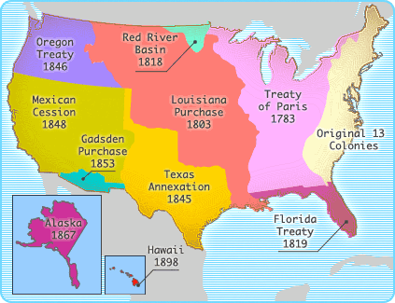Define Manifest Destiny:
2. Use the map below to answer the following questions.



1. Which area on the map was acquired by the United States as a result of the Mexican-American War?
2. Which area on the map includes the original 13 colonies and the land that was ceded to the United States by Great Britain following the American Revolution?
3. Which area on the map was purchased from France in 1803 and gave the United States control of the Mississippi River?
4. Which area on the map includes the Oregon Territory?
5. In the space below, list the major reasons why each group of people moved west.

**Farmers-**

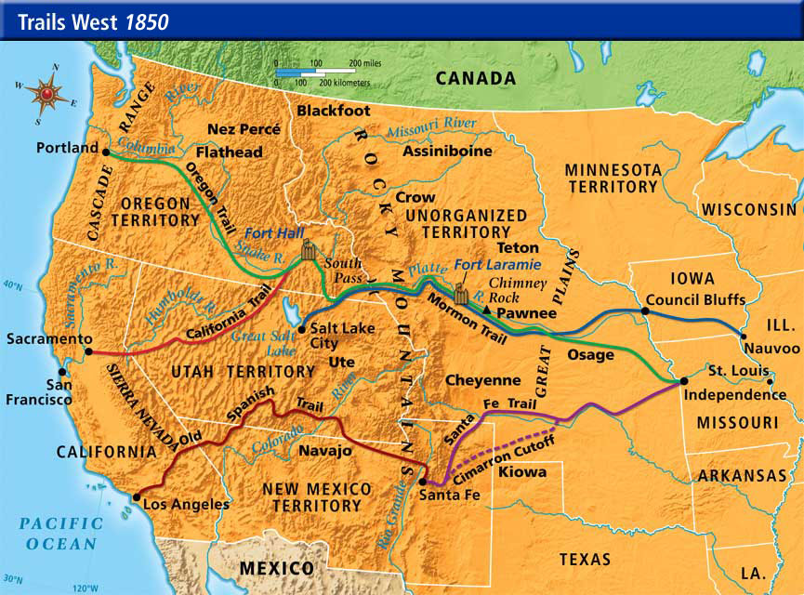

**Cowboys-**

**49ers-**

**Mormons-**

**Railroad Workers-**

1. Complete the chart below about American Reformers by filling in the missing information.

**American Reformers**

|  |  |  |
| --- | --- | --- |
| **Goal** | **Leaders** | **Impact in the United States** |
| Reforms for the mentally ill |  | Improved treatment of the mentally ill. People with mental illness were placed in hospitals and treated as patients, not criminals. |
|  | Dorothea Dix | Improved prison conditions and stopped treatment of debtors as criminals. |
| Stop Alcohol Abuse | Temperance Movement |  |
| Improve Education |  | By the 1850s, most northern states set up free tax-supported elementary schools. |
|  | Abolitionist movement– Frederick Douglass, William Lloyd Garrison, the Grimke Sisters, and Harriet Tubman | Demanded that slavery be abolished in the U.S. and backed it up with courageous actions (such as Harriet Tubman and the Underground Railroad) |
| Women’s Rights | Elizabeth Cady Stanton, Sojourner Truth, and Susan B. Anthony |  |

**Causes of the Civil War**

**Sectionalism –** The North, South, and West each developed its own unique way of life. People in each section felt loyalty towards their own section rather than to the country as a whole.

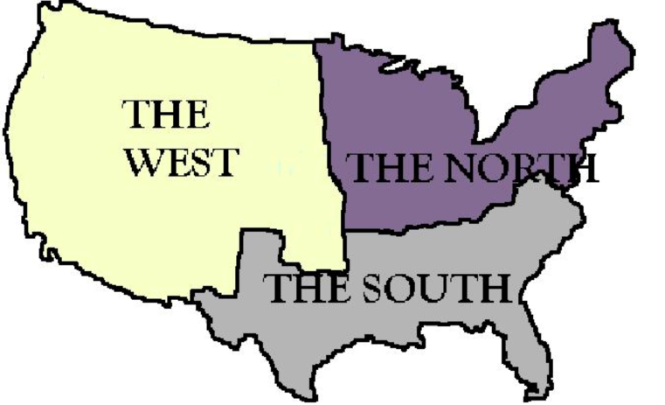**North –** Rise of factory system. Became a center of manufacturing and industry in the United States. Wanted the government to raise taxes on imported goods (tariffs) and protect their trade.

**South –** Agriculture and slavery dominated the South’s economy. Plantation agriculture (especially cotton) based on slave labor. Wanted the government to protect slavery and opposed tariffs.

**West –** People worked on small farms. Wanted the government to keep funding transportation improvements like roads and canals and keep providing land at cheap prices.

1. In the spaces below, list the region of the United States (North, South, West) depicted in each image.

_________ 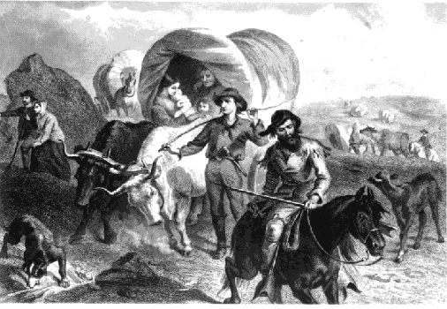 _________ 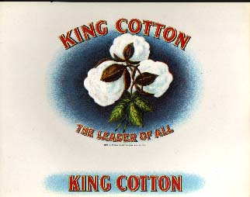

_________ 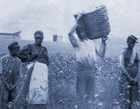 _________ 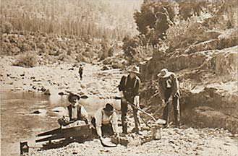

_________ 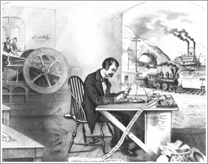 _________ 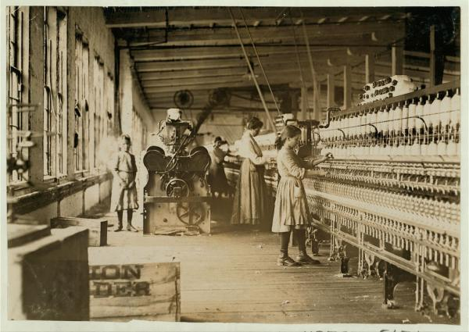

1. Complete the chart below.

|  |  |  |  |
| --- | --- | --- | --- |
| **Compromise** | **Viewpoint of North** | **Viewpoint of South** | **Effect / Significance** |
| Missouri Compromise (1820) |  |  |  |
| Compromise of 1850 |  |  |  |
| Fugitive Slave Law (1850) |  |  |  |
| Kansas Nebraska Act (1854) |  |  |  |
| Dred Scott v. Sanford (1857) |  |  |  |