**U.S. History Quarter 1 Study Guide**

**Reasons for European Exploration**

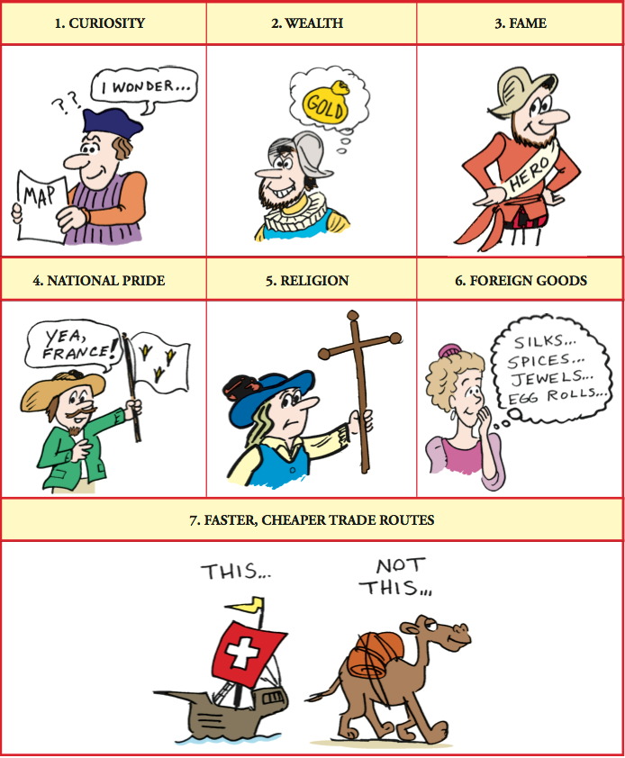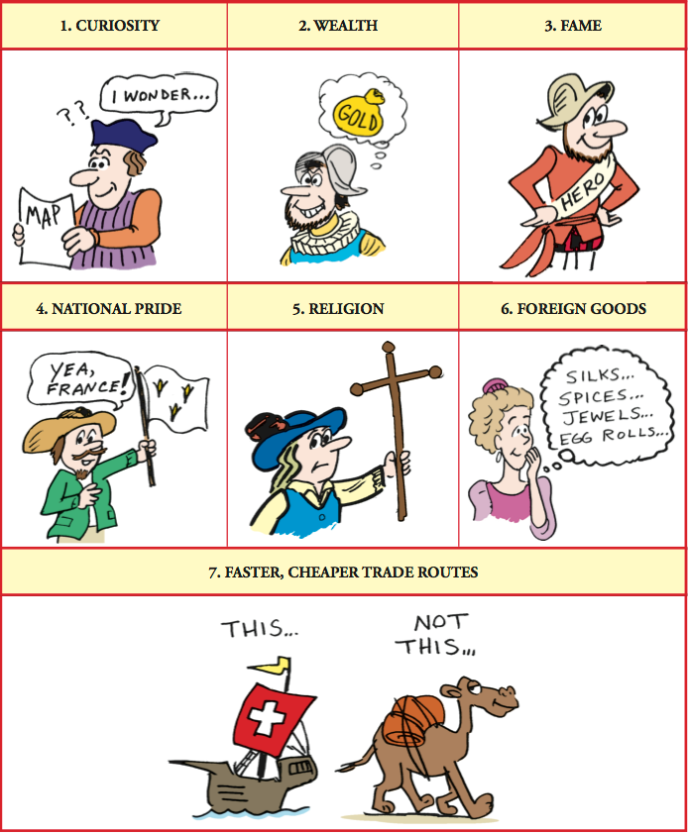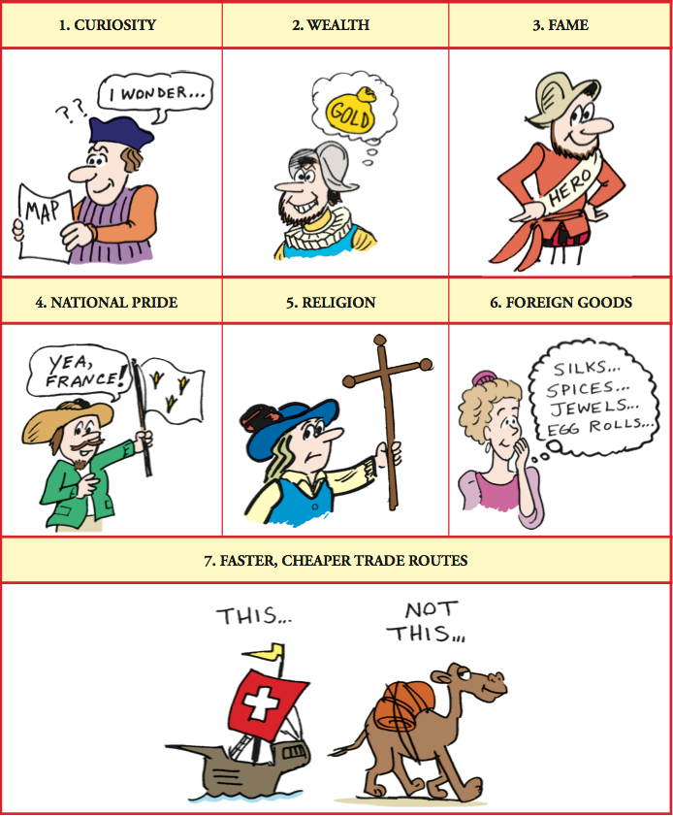

\

1. What motivated each of the following European countries to explore the New World?

Spain-

France-

England-

**Colonization**

1. In the space provided, explain the significance of the following dates:

**1607**

___________________________________________________________________

**1620**

___________________________________________________________________

1. What was the first permanent English colony in North America? (71)
2. Complete the table below

|  |  |  |
| --- | --- | --- |
| **Colony** | **Founder(s)** | **Reasons for Settlement** |
| **Massachusetts** |  |  |
| **Rhode Island** |  |  |
| **Connecticut** |  |  |
| **New York** |  |  |
| **Pennsylvania** |  |  |
| **Maryland** |  |  |
| **Virginia** |  |  |
| **Georgia** |  |  |

1. Which two individuals were banished for disagreeing with teachings of the Puritan Church? (79)
2. Match each of the descriptions below to the correct region of the 13 colonies

______ A safe place for people of all races and religious groups

______ Plantations

______ Less fertile land

______ Known as the “Bread Basket”

**A. New England Colonies**

**B. Middle Colonies**

**C. Southern Colonies**

______ Fishing and whaling

______ Small farms/subsistence farming

______ Grains and wheat

______ Lumber, ship building, good natural harbors

______ Rocky soil

______ Highest number of slaves

______ Tobacco farms



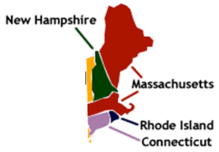______



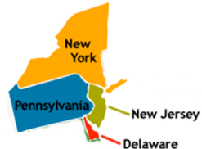______

**Free Enterprise-**

**An economic system in which government intrusion in the economy is limited**



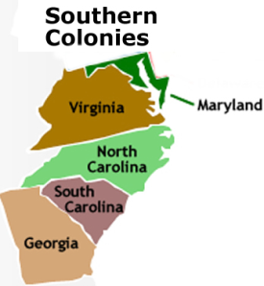______

1. The ___________________ was a religious movement that swept through the 13 colonies during the 1730s and 1740s and emphasized the power of religion in people’s lives.
2. Define Mercantilism:
3. Define Salutary Neglect:
4. 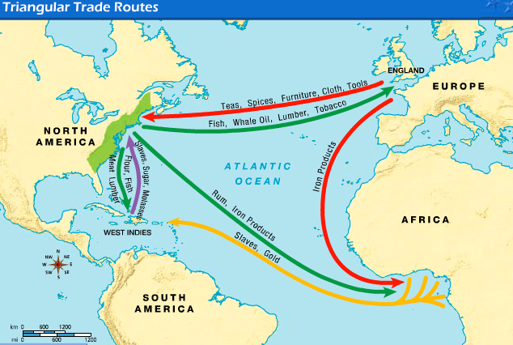Define Triangular Trade:

**Key Documents**

1. Match each of the following descriptions with the correct document

|  |  |  |  |  |
| --- | --- | --- | --- | --- |
| **Mayflower Compact** | **Magna Carta** | **Virginia House of Burgesses** | **English Bill of Rights** | **Fundamental Orders of Connecticut** |

_______________ First representative assembly in the colonies

_______________ First written Constitution in the colonies

_______________ Written by the Pilgrims in 1620 to promote self government

_______________ Written to limit the King’s power and includes the protection from excessive bail

_______________ Written in 1215 to limit the King’s power as well as guarantee a right to trial by jury

1. Which of the following would be the best title for the chart below?

**Mayflower Compact**

**Virginia House of Burgesses**

**New England town meetings**

A) Attempts to Overthrow British Rule

B) Development of Self-Government in the Thirteen Colonies

C) Establishment of British Parliamentary Control Over the Colonies

D) Social Reform Movements in the Thirteen Colonies

**French and Indian War**

*After French & Indian War*

*Before French & Indian War*

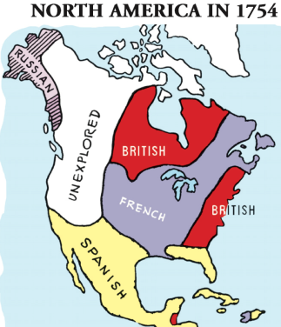

1. 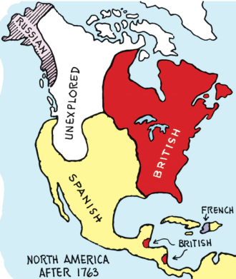Describe the results of the French & Indian War

**Causes of the American Revolution**

1. Match each of the following descriptions with the correct event from the word bank

|  |  |  |
| --- | --- | --- |
| **Proclamation of 1763** | **Quartering Act** | **Stamp Act** |
| **Townshend Acts** | **Boston Massacre** | **Boston Tea Party** |
| **Intolerable Acts** | **First Continental Congress** | **Lexington and Concord** |

________________ First shots of the American Revolution “Shot Heard Round the World”

________________ Forbid the colonists from settling on land west of the Appalachian Mountains

________________ Passed to punish colonists after the Boston Tea Party

________________ Organized by the Sons of Liberty to protest the Tea Act. Colonists raided British ships and dumped hundreds of cases of tea into Boston Harbor

________________ Indirect tax on glass, lead, paper, and tea. Colonists reacted with a boycott

________________Required colonists to allow British soldiers to stay in their homes

________________ Colonists in Boston began to harass British troops. The soldiers responded by firing on the colonists, killing five people

________________ Required the colonists to pay a tax on all printed materials. Colonists reacted with a boycott

________________ Representatives from the colonies met to present their complaints to the British and organized a boycott of all trade with England

1. Colonists who wanted to break away and rebel from England were called ___________________
2. Colonists who wanted to stay loyal and support England were called _______________________
3. What slogan did many colonists cry to protest the taxes imposed by England? (145)

**Important Individuals**

1. John Locke ____________________________________________________________________
2. Charles de Montesquieu __________________________________________________________
3. William Blackstone ______________________________________________________________
4. John Adams ___________________________________________________________________
5. Abigail Adams __________________________________________________________________
6. Crispus Attucks _________________________________________________________________
7. Patrick Henry __________________________________________________________________
8. Samuel Adams _________________________________________________________________
9. Mercy Otis Warren ______________________________________________________________

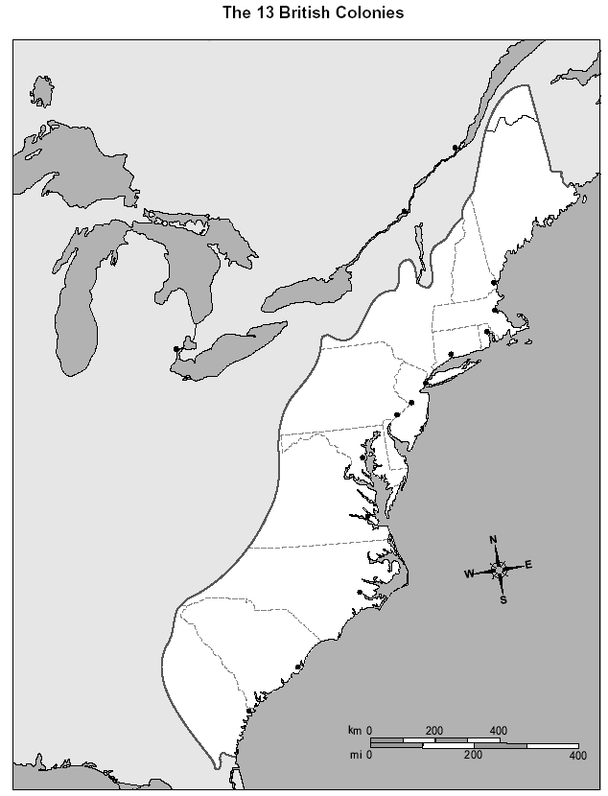**Label the 13 Colonies:**

# New England Colonies

1. New Hampshire
2. Massachusetts
3. Rhode Island
4. Connecticut

# Middle Colonies

1. New York
2. New Jersey
3. Pennsylvania
4. Delaware

# Southern Colonies

1. Maryland
2. Virginia
3. North Carolina
4. South Carolina
5. Georgia

**Label:**

1. Appalachian Mtns
2. Ohio River Valley
3. Atlantic Ocean
4. Canada
5. Where were most of the major colonial settlements located? Why did colonists choose to settle in these areas?