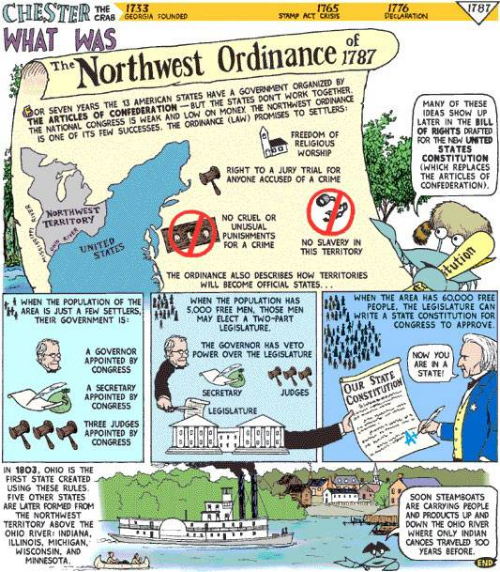

1. How many men does it take for a two-part legislature to be elected?

2. What can the territory do when the population reaches 60,000?

3. What is the first state created using the rules of the Northwest Ordinance?

4. How many other states are formed?

5. Who inhabited the lands before they were divided up by the United States?

