Factory System
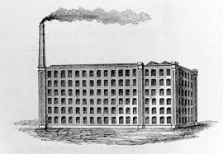
In 1789, the Englishman Samuel Slater sailed to the United States under a false name. It was illegal for textile workers like him to leave the country. Britain wanted no other nation to copy its new machines for making thread and cloth. But Slater was going to bring the secret to America.
The factory system brought many workers and machines together under one roof. Most factories were built near a source of water to power the machines. People left their farms and crowded into cities where the factories were. They worked for wages, on a set schedule. Their way of life changed, and not always for the better.
Many Americans did not want the United States to industrialize, but the War of 1812 led the country in that direction. Because the British naval blockade kept imported goods from reaching U.S. shores, Americans had to start manufacturing their own goods. The blockade also stopped investors from spending money on shipping and trade. Instead, they invested in new American industries. Taking advantage of the country’s free enterprise system, American businessmen built their own factories, starting in New England. These businessmen and their region grew wealthier.
New England was a good place to set up factories for several reasons. Factories needed water power, and New England had many fast-moving rivers. For transportation, it also had ships and access to the ocean. In addition, New England had a willing labor force. The area’s first factory workers were families who were tired of scraping a living from their stony fields.
Samuel Slater built his first spinning mill in Pawtucket, Rhode Island, in 1790. He hired eight children between the ages of 7 and 12, paying them a low wage. Later, he built a larger mill and employed whole families. As Slater influenced others to start mills, his family system of employment spread through Rhode Island, Connecticut, and southern Massachusetts.
Cotton Gin
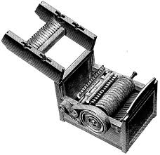
Eli Whitney invented a machine for cleaning cotton in 1793, after visiting the Georgia plantation of Catherine Greene, the widow of a Revolutionary War general. Mrs. Greene was struggling to make her plantation profitable. English textile mills had created a huge demand for cotton, but the short-fibered cotton that grew in most parts of the South was hard to clean by hand. A worker could clean just one pound of this cotton in a day.

Whitney’s cotton gin (short for “engine”) made the cotton-cleaning process far more efficient. With the new machine, one worker could now clean as much as 50 pounds of cotton a day. The cotton gin helped set the South on a different course of development from the North. It made short-fibered cotton a commercial product and changed Southern life in four important ways.

- It triggered a vast move westward. Cotton farming moved beyond the Atlantic coastal states, where long-fibered, easy-to-clean cotton grew. Cotton plantations began to spread into northern Florida, Alabama, and Mississippi. Then they crossed into Louisiana and Arkansas. After 1840, they reached Texas.

- Because cotton was valuable, planters grew more cotton rather than other goods, and cotton exports increased.

- More Native American groups were driven off Southern land as it was taken over for cotton plantations.

- Growing cotton required a large work force, and slavery continued to be important as a source of labor. Many slaves from the east were sold south and west to new cotton plantations. As cotton production increased, the number of enslaved people in the south rose greatly.
Interchangeable Parts
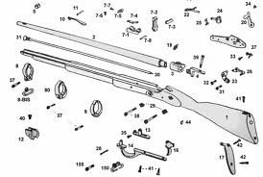
In 1797, the U.S. government hired the inventor Eli Whitney to make 10,000 muskets for the army. He was to have the guns ready in two years. Before this time, guns were made one at a time by gunsmiths, from start to finish. Each gun differed slightly. If a part broke, a new part had to be created to match the broken one.

Whitney sought a better way to make guns. In 1801, he went to Washington with a box containing piles of musket parts. He took a part from each pile and assembled a musket in seconds. He had just demonstrated the use of interchangeable parts, parts that are exactly alike.

Machines that produced exactly matching parts soon became standard in industries. Interchangeable parts speeded up production, made repairs easy, and allowed the use of lower-paid, less-skilled workers. Before long, goods were being produced faster and cheaper than they ever had been before.

Mechanical Reaper
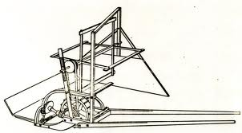
Not long after Eli Whitney invented the Cotton Gin, Cyrus McCormick invented another significant agricultural invention that revolutionized farming, the mechanical reaper. Before this invention, reaping was a very difficult process which was done by hand using scythes and sickles and greatly limited the amount a grain that a farmer could harvest. The mechanical reaper was a new type of farm equipment that was pulled by horses to cut small grain crops. It was developed to cut down wheat more quickly and more efficiently.
The initial idea and design for the reaper actually came from Cyrus McCormick's father, Robert, who worked on the invention for 16 years. In 1831, twenty-two-year-old Cyrus took over his father's project and, within six weeks, he had built, field-tested, remodeled, and successfully demonstrated the world's first mechanical reaper. McCormick's invention automatically cut, threshed, and bundled grain while being pulled through a field by horses.
In 1834, inventor Cyrus McCormick took out a patent on his invention and, soon after, began manufacturing the reaper himself. McCormick spent years making improvements to the mechanical reaper invention and coming up with business innovations to boost sales. By 1851, Cyrus McCormick's mechanical reaper invention was an international sensation.

Steel Plow
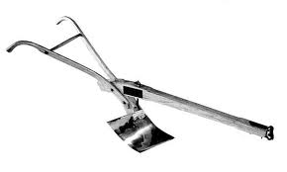
In 1836, the blacksmith John Deere invented a lightweight plow with a steel cutting edge. Older cast-iron plows were designed for the light, sandy soil of New England. Deere noticed that cast-iron plows being used at the time in his home of Illinois often came to him for repairs and he realized that they did not work very well in the prairie soil. The rich, heavy Midwestern soil clung to the bottom of these plows and slowed farmers down.

One day, a broken steel sawmill blade gave John Deere an opportunity. He knew that days in the field were difficult for farmers near his home in Illinois, because they had to interrupt their work to clean the sticky and heavy Midwestern prairie soil off of their cast-iron plows. Deere took the broken steel sawmill blade and fashioned it into a cutting edge for his plow. Deere’s new steel plow made preparing ground much less work.

As a result of John Deere’s steel plow, more farmers began to move to the Midwest. His invention helped make the Midwestern United States one of the world's great farming regions. By 1855, Deere’s factory was selling more than 10,000 plows a year. These famously came to be known as “The Plow that Broke the Plains”.

Steamboat
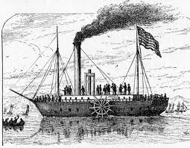
America’s transportation system went through important changes during the Industrial Revolution. Steamboats carried people and goods farther and faster and led to the growth of cities like New Orleans and St. Louis. Robert Fulton invented a steamboat that could move against the current or a strong wind. He launched the Clermont on the Hudson River in 1807. Its steam engine turned two side paddle wheels, which pulled the boat through the water.

The Clermont was dubbed “Fulton’s Folly” and described as “looking precisely like a backwoods saw-mill mounted on a scow [boat] and set on fire.” But it made the 300-mile trip from New York to Albany and back in a record 62 hours. Even Fulton had not expected to travel so quickly.

In 1811, the first steamship traveled down the Mississippi and Ohio rivers. But its engine was not powerful enough to return upriver, against the current. Henry Miller Shreve, a trader on the Mississippi, designed a more powerful engine. He installed it on a double-decker boat with a paddle wheel in the back. In 1816, he sailed this boat up the Mississippi and launched a new era of trade and transportation on the river.

Telegraph
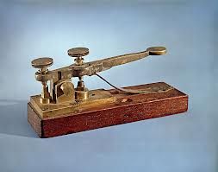
In 1837, Samuel F. B. Morse first demonstrated his telegraph. This machine sent long and short pulses of electricity along a wire. These pulses could be translated into letters of a message. Samuel Morse developed a code (called Morse Code) that assigned a set of dots and dashes to each letter of the English alphabet and allowed for the simple transmission of complex messages across telegraph lines.

Morse Code assigned letters in the alphabet and numbers a set of dots (short marks) and dashes (long marks) based on the frequency of use. Letters used often (such as “E”) got a simple code, while those used infrequently (such as “Q”) got a longer and more complex code. Initially, the code, when transmitted over the telegraph system, created marks on a piece of paper that the telegraph operator would then translate back into English. Rather quickly, however, it became apparent that the operators were able to hear and understand the code just by listening to the clicking of the receiver, so the paper was replaced by a receiver that created more distinct beeping sounds.

In 1843, Morse received funding from the U.S. Congress to set up and test the telegraph system between Washington D.C. and Baltimore, Maryland. On May 24, 1844, Morse sent the historic first message that said: “What hath God wrought?” The first long-distance telegraph line also carried news from Baltimore to Washington D.C. about who had been nominated for president. With the telegraph, it took only seconds to communicate with someone in another city. Telegraph lines spanned the country by 1861, bringing people closer as a nation. By 1866, a telegraph line had been laid across the Atlantic Ocean from the U.S. to Europe.
Erie Canal
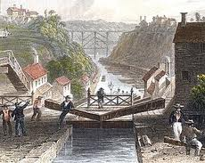
In the early 1800s, it was easier and cheaper to ship goods by water than by land. In 1816, Dewitt Clinton (the Governor of New York) proposed a 360 mile canal connecting Lake Erie to the Hudson River. Farmers could then ship goods from the Great Lakes to New York City entirely by water. After a long and heated debate, state lawmakers voted to build the canal.

The Erie Canal was the most ambitious project ever constructed in the United States up to that time. A path 50 feet wide had to be cut through forests, swamps, and hills. Then a ditch 40 feet wide and 4 feet deep had to be dug. The canal was an important modification of the physical environment. Without the heavy equipment we have today, thousands of workers were needed to cut trees, rip out tree stumps, blast through rock, and dig the canal. One out of every four workers was Irish. At the peak of construction, more than four thousand workers were laboring on the canals. Canal workers earned about $10 a month in 1832.

In order to pass through the mountains and come down gradually to the level of elevation (height) of the Hudson River, the engineers of the canal designed a series of locks. These locks were spaces that could be closed off. They acted like giant bathtubs in which boats could be raised and lowered with the water.

After seven years, the Erie Canal was completed in 1825. Barges were pulled slowly through the canal by mules. Cities along its route grew and prospered. Western farmers could now send goods from the Great Lakes along the canal and down the Hudson River. New York City grew to become the nation’s largest city.

