Invention/Innovation | Inventor | Area | Drawing
Factory System- (325)  Brought all modes of production together under one roof | Samuel Slater brought the plans from Great Britain | Northeast | 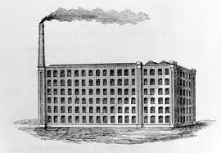
Cotton Gin- (333)  Removed the seeds from cotton fibers  (50lbs a day with/ 1lb w/o) | Eli Whitney | South | 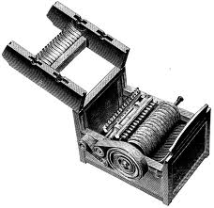
Interchangeable Parts- (327)  Thing could be made easier, cheaper, and fixed faster | Eli Whitney | Northeast | 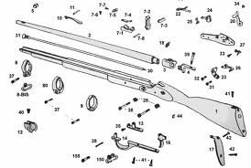
Mechanical Reaper- (329)  Made the harvesting of grain much faster  (1 acre in one hour with/1/2 acre in a day w/o) | Cyrus McCormick | (Mid)West | 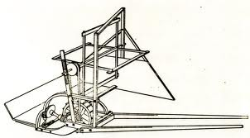
Steel Plow- (329)  Helped farmer open up more land to plant more acres | John Deere | (Mid)West | 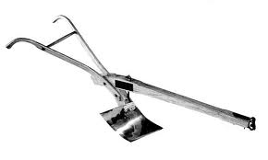
Steamboat- (328)  Help improve river travel especially upstream, reduced cost of shipping goods | Robert Fulton (perfected the commercial steamboat) | All Regions | 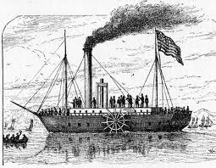
Telegraph- (323/329)  Improved communication, allowed business to check prices and supply | Samuel Morse | North and West | 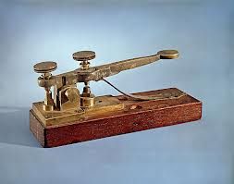
Erie Canal- (322/339)  Artificial waterway that connected the Great Lakes with Atlantic Ocean, reduced cost of shipping goods | Dewitt Clinton (Governor of New York) | North and West | 