GT Project- Reconstruction Road Map
On a separate sheet of paper, create an illustration or model of a road that shows the important events of Reconstruction and their impact on African Americans’ journey toward full citizenship. Your road should:
- Show the path of Reconstruction, including progress and setbacks that African Americans experienced in their struggle for full citizenship during Reconstruction

- Include along the path at least 15 events during Reconstruction with 3 events from each phase of Reconstruction. Use the space below to plan your road map.
- The End of Reconstruction
Event 10-
Event 11-
Event 12-
- Reconstruction Reversed
Event 13-
Event 14-
Event 15-

- Presidential Reconstruction
Event 1-
Event 2-
Event 3-
- Congressional Reconstruction
Event 4-
Event 5-
Event 6-
- Southern Reconstruction
Event 7-
Event 8-
Event 9-

- For each event include
  - Name of the event
  - Short explanation/description
  - Symbol, picture, or 3D feature that indicates the impact on African American citizenship
    - fast speed limit signs, green lights, low incline can be used for progress
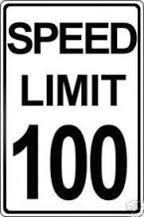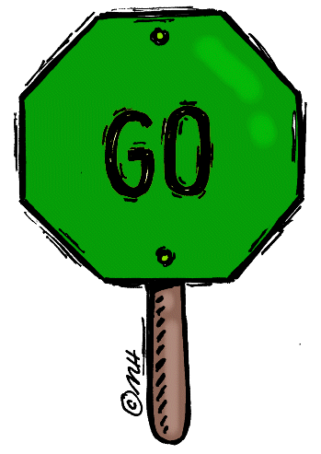
    - detours, stop signs, potholes, roadblocks, construction, steep incline can be used for setbacks
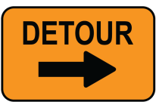
- Your map should have a title and caption
  - The caption should be at least 3-5 sentences
  - The caption will summarize how Reconstruction brought African Americans closer to full citizenship. In what ways did African Americans get closer to full citizenship during Reconstruction? In what ways did African Americans not yet achieve full citizenship?

- Your map must be colorful, neat, and free from spelling errors
  - Layout is important
    - Plan your space so that you have room for all events, vocabulary, and the caption
    - All labels, explanations, and captions should be written neatly
  - Think creatively
    - Think of the events of Reconstruction as a part of a road or journey that African Americans experienced. How could pictures, symbols, or 3D objects be used to represent each part of this road? You may use paper, cardboard, clay, or other materials to create your road map.

- Class time must be used wisely!
Grading Rubric
 | 20 Points | 15 Points | 10 Points | 5 Points
Name and Explanation of Events | Name & explanation for all 15 events on road map | Name & explanation for 10-14 events on road map | Name & explanation for 5-9 events on road map | Name & explanation for 1-4 events on road map
Symbol or Picture of Event | Picture or symbol for all 15 events on road map | Picture or symbol for 10-14 events on road map | Picture or symbol for 5-9 events on road map | Picture or symbol for 1-4 events on road map
Title and Caption | Title and impressive caption (3-5 sentences) | Title and accurate caption (3-5 sentences) | Title and caption are included, but may be somewhat inaccurate or too short (less than 3-5 sentences) | Title and/or caption may be missing or inaccurate
Quality of Work | High quality work, colorful, neat, no spelling errors, eye catching design | Colorful design, although product may be somewhat unorganized and/or may have errors | Little color is used and/or messy design, several errors that impact the quality of work | Color is not used, messy design, and many spelling errors
Class Participation | Prepared every day, used class time wisely, required no redirection | Used class time wisely and required no redirection but was not always prepared | Did not always use class time wisely and required some redirection to stay on task | Wasted class time and/or caused disruptions

Score: ____________

