**Spain Takes the Lead**



Finding a Northwest Passage (an all water route) to Asia was the goal of most European countries. Asia possessed valuable silks and spices that many Europeans desired. If one of the European countries gained control of these products, they would create a trade monopoly and become the most powerful country in the world! The race was on. Christopher Columbus believed that if he sailed west he would reach Asia. The king and queen of Spain financed his voyages in search of Asia. He set sail with three ships and in ten weeks sighted land. Believing he had arrived in India, Columbus claimed the land for Spain and called the natives living there Indians. What he really discovered was America. He actually landed in America on an island in the Bahamas.

The discoveries of explorers such as Columbus inspired many European nations to take to the open seas. Spain led the way. The Spanish explored for “God, Gold, and Glory.” The few fortunate conquistadors (a Spanish conqueror or adventurer) who found gold and glory in Central and South America conquered ancient people, robbed them of their gold and precious jewels, and destroyed their civilizations. Other Spaniards found nothing but suffering and death in the New World.

As soon as new lands were conquered, Spanish missionaries arrived and sought to convert the native populations to Catholicism. Ships loaded with gold and jewels sailed back east to Spain carrying more riches than people could imagine. Men eager to find treasures chased rumors across the Americas. They were not as lucky as early conquistadors, but they helped Spain build a huge empire in the Americas. Spain had certainly hit the jackpot, it claimed many lands half a world away and the Spanish treasury was overflowing with gold.

**Spain Visual**



**France**

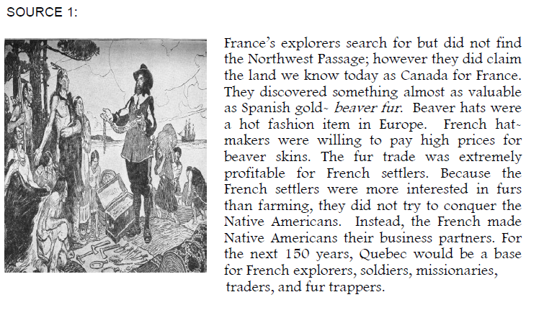

**France Visual**



**England**

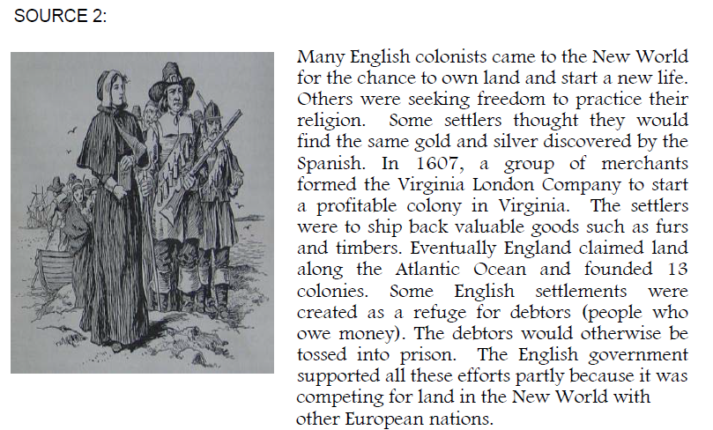

**England Visual**

**snnt**